**Rosliston Parish Council**

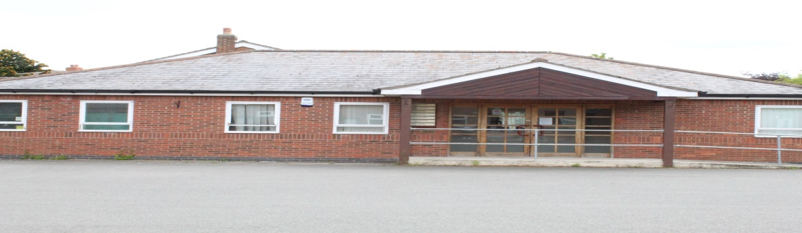

|  |  |  |  |  |  |  |  |  |  |  |  |  |  |  |  |  |
| --- | --- | --- | --- | --- | --- | --- | --- | --- | --- | --- | --- | --- | --- | --- | --- | --- |
|  | Rosliston Medical Centre is up for sale at a guide price of £250,000   |  |  |  | | --- | --- | --- | | 1) | Would you like to see the building being used by the community? | Yes / No | | 2) | If yes, which of these options interests you:-   * Chiropody * Office space * Meeting room * Therapy services (occupational/physiotherapy) * Other. Please enter any suggestions   ……………………………………………………….  ……………………………………………………… | Yes / No  Yes / No  Yes / No  Yes / No | | 3) | If yes, would you like to see a “community buy-in”? | Yes / No | | 4) | Do you have any suggestions on how funding could be raised? If you have suggestions please list:  ……………………………………………………….  ………………………………………………………. | Yes / No | | 5) | Would you be willing to contribute towards the cost? | Yes / No | |

**Privacy: Your individual views will not be shared with anyone outside of the Rosliston Parish Council, who are bound by a Code of Conduct.**

Thank you for completing. Please email your response to [clerk@roslistonparishcouncil.org.uk](mailto:clerk@roslistonparishcouncil.org.uk)

**Or** drop in the letter box at 58A Main Street Rosliston DE12 8JW.

**Closing date : Sunday 9th June**